**WEB-BASED MEMBERSHIP APPLICATION SYSTEM WITH SMS NOTIFICATION FOR CAPEDA DRIVERS**

**OF CAMELLA HOMES**

A Capstone Project

Submitted to the Faculty of

Department of Information Technology

Cavite State University

Imus City, Cavite

In partial fulfillment

of the requirements for the degree of

Bachelor of Science in Information Technology

**LUCION, MAXINE S.**

**PITOGO, SHARLYN CLAIRE S.**

**SORIANO, ERIC YEOJ H.**

June 2023

**INTRODUCTION**

A Web-based membership system is a pivotal tool for organizations, offering an efficient means to add, store, manage, and update members' information in a centralized database. This study focuses on the development of a Web-based membership application system with integrated SMS capabilities to streamline and modernize the membership management process.

CAPEDA has a rich history dating back to 1986 when it was founded by Pablo Guerrero. Comprising pedicab drivers, CAPEDA has played a vital role in providing daily transportation services to the residents of various areas in Camella Bacoor. Over the years, the pedicab, originally a manually operated "padyak," has evolved into electric-powered bikes, known as E-bikes. In the present year, CAPEDA boasts a membership of 500 individuals, with the majority having transitioned to E-bikes as the primary source of power for their pedicabs.

Pedicabs stand out as a financially and environmentally friendly mode of transportation, positioning themselves as a viable alternative to traditional, smoke-emitting vehicles in terms of mobility. They are a common sight in Philippine cities and local areas. As pedicabs gain popularity among commuters, more Filipinos with basic driving skills are drawn to this occupation as a means of making a living.

As the population of pedicab drivers within CAPEDA continues to expand, the membership application process and the collection and preservation of member data have become increasingly arduous. The organization's current membership procedure demands a substantial investment of time and effort, affecting both CAPEDA officers and prospective members alike. Moreover, their data recording relies heavily on manual transcription into Microsoft Word documents for each member. This not only hampers efficiency but also exposes the organization to inefficiencies such as data loss, security threats, and potential data breaches.

Recognizing these challenges, this research endeavors to provide a solution by developing a Web-based Membership Application System. The primary goal is to enhance CAPEDA’s membership application process, data collection and management process, ensuring a more convenient and streamlined experience for both the organization's staff and its members. This system aims to usher CAPEDA into the digital age, eliminating the dependence on manual record-keeping, reducing errors, and improving the overall efficiency of managing their growing membership.

**Project Context**

Due to the growing population of the drivers, the auditor of CAPEDA Org. is having a hard time managing the information relevant to the organization. In view of the fact that the auditor usually does their job without any assistance from someone more tech savvy, their way of organizing information is by using their personal desktop and the Microsoft Word. With this approach, manually typing in personal information from members and new applicants will slow them down, and it’s only a matter of time before their workload will pile up. Searching and modifying information in a timely manner will become burdensome since packs of data are stored in their computer, causing for it to load slower. Unforeseen mistakes and incidents are likely to occur, which could result to data being lost, putting their organization’s records at high risk.

**Purpose and Description**

The study was conducted to know the needs of the organization to improve the membership application process for the CAPEDA. The researcher developed a web-based system that will aid the organization’s needs to provide a convenient and accessible platform for the members and organize the application processes. This project has helped the CAPEDA to increase efficiency and accuracy in handling data, and have an easier and faster way of managing the organization; this system has benefitted both the client and the users.

**Objective of the study**

Generally, this study aimed to help CAPEDA to have an efficient and effective way of handling membership application as well as the handling of data and information of the organization and its constituents.

Specifically, this study aims to:

1.    Plan the desired system by discussing how the current information management works, outline the requirements, brainstorm a feasible alternative, consider the modules and components needed, as well as their usage.

2.   Design a web-based system that will replace the manual process of managing membership applications. In this phase, the proponents will present a flowchart with the objective of gathering feedbacks from the client.

3.   Develop the system using the propositions approved by the client.

4.   Test the developed system by evaluating and assessing it for possible bugs and logic errors. This phase requires a lot of time as it is the stage wherein both the proponents and the client would have to communicate and analyze the system thoroughly.

5. Deploy the system to the end users. In this phase, the system will be accessible to both applicants and existing members of CAPEDA.

6. Maintain the deployed system continuously when adjustments or updates are necessary.

**Scope and Limitation**

This study aimed to construct a better way of managing CAPEDA members and applicant’s information. This web-based membership system allows its affiliates to manage their membership and registration process digitally. The system will have three user types: Applicant, Member, and Admin. The Applicant account can be accessed by users that aren’t registered as a pedicab driver under CAPEDA. The Member account can only be accessed by users that are registered under CAPEDA. The Admin account can only be accessed by the organizations’ officers.

The following are the modules of the system along with its feature:

**Account Modules:**

**1. User Authentication:** This pivotal module is responsible for validating user accounts attempting to access the system. The system accommodates three distinct user types, each with varying levels of authorization. Firstly, the "Applicant" is the entry-level user type, granted access to limited features. Next, the "Members" category includes individuals who have successfully passed the screening process and received approval from the organization's officers or administrators. Lastly, "Admins" possess the highest authority, enabling them to manage critical information related to both members and applicants.

**2. Registration:** The system offers two modes of account registration, catering to different user preferences and needs. The first method is "User-Generated Registration," allowing applicants to create their own accounts and initiate the verification process. However, simply verifying their email does not guarantee immediate access to the system. Upon email verification, administrators will review and either approve or deny the application. Approved applicants gain access to the applicant dashboard, where they can upload the required documents for membership. In contrast, denied applications receive notifications about the status of their submission. The second registration method is "Admin-Generated Accounts," designed for applicants who may not be proficient in using computers. Administrators generate accounts on their behalf, including email verification, and oversee the application process. Admin-generated accounts are assigned temporary passwords, which are provided to the applicants for future access to their accounts.

**Member-Related Modules:**

**1.Applicant Module** – This module is designed exclusively for users who meet the eligibility criteria for membership application. Within this module, eligible applicants have the opportunity to upload the requisite documents as specified by the organization's officers. Once the applicants have successfully uploaded their required documentation, administrators will conduct a comprehensive review to ensure the completeness and validity of the submitted materials.

Upon verification and confirmation that all necessary documents are in order, the administrators will facilitate the next steps in the membership application process. This typically includes scheduling an appointment for the applicants to visit the organization's premises in person, where they can finalize their membership and process the associated membership fees.

1. **Member Module** – this module will be accessible only for the members of the CAPEDA, in this module they can edit their personal information with restrictions, change their password, and upload documents if the officers request some.

**Admin-Related Modules:**

1. **Admin** **Module –** is exclusively accessible to the officers of CAPEDA, granting them comprehensive control over the organization's digital operations. Within this module, administrators possess a range of pivotal functionalities designed to streamline and enhance administrative tasks:

* **Account Creation:** Administrators have the authority to create user accounts for applicants, particularly for those individuals who may not be proficient in digital processes, ensuring that no eligible candidate is excluded from the membership application process.
* **Member Management:** Administrators can efficiently monitor and manage the growing roster of CAPEDA members. This includes overseeing their profiles, ensuring data accuracy, and addressing member-specific needs.
* **Requirements Management:** This module empowers administrators to dynamically manage the list of required documents, enabling them to add, modify, or update the essential documentation necessary for the application and membership process.
* **Announcement Creation:** Administrators can craft, update, and disseminate announcements to the CAPEDA community, ensuring that all members and applicants stay informed about essential organizational news, events, and alerts.
* **Document Monitoring:** The Admin Module provides a critical overview of all uploaded documents, both from applicants and members. Administrators can review, download, and evaluate these documents to facilitate the application and membership verification process.

The modules in each category are related by their functions and the roles they serve in the web-based membership application system. The "User Authentication Module" deals with user login and access control. The "Member-Related Modules" are focused on tasks and features available to CAPEDA members. The "Admin-Related Modules" are designed for administrators to manage applicants, members, requirements, announcements, and document submissions.

While the system developed by the proponents offers significant advantages, it also has certain limitations, including:

1. **Exclusive Scope:** The system is designed exclusively for CAPEDA Org, limiting its application to this specific organization. As a result, it may not be readily adaptable for use by other entities or organizations with different operational needs.
2. **Focused Purpose:** The primary focus of the system centers on streamlining and enhancing the membership process for the drivers of CAPEDA Org. While this purpose aligns with the organization's core objectives, it means that the system may not cater to a broader range of functions beyond membership management.
3. **Restricted Access:** Access to the system is restricted solely to members of CAPEDA Org. This limitation ensures that only authorized individuals can interact with the system's features, safeguarding sensitive information and maintaining the integrity of the membership process.

These limitations serve to define the system's boundaries and should be considered when assessing its applicability to other organizations or use cases.

**REVIEW OF RELATED LITERATURE**

**Related Literature**

**BookNow Software. (2023) *Key Benefits of Member Management Software*.**

According to an article for BookNow Software, having a member management system produce positive impacts for the business and its components. By having a software that will help with the management of data and information, businesses are more likely to perform better. It also attracts potential customers/members because it enables transparency by making sure members are able to see every detail they need to see. Also, this type of softwares provides peace of mind in exploring new ways of improving businesses. BookNow Software (2023).

**Davies Genealogy. (2019) *Advantages of Online Applications*.**

As indicated by an article published by Davies Genealogy, it is vital to understand that online applications are helping various organizations to accumulate qualified applicants and enhancing the overall candidate experience. Physically applying for a job can be time consuming and expensive, however, you have an opportunity to reduce all that by using online application platforms.

**Related Study**

**Usanto, U., Nurlaela, L., Sopian, A., & Alfiah, F. (2022). Umrah Registration System Using Extreme Programming Method Towards Worship Tourism. *International Journal of Cyber and IT Service Management*, *3*(1), 22–31.**

                     A study conducted in 2022 paved the way for enhanced method of handling registration applications by developing a Registration System that helped with the daily transactions and handling of big amounts of data. It was also shown that having such a system helped the business to store big amounts of data, it also helped with the time consumption regarding the transaction processes of the business. usanto, U., Nurlaela, L., Sopian, A., & Alfiah, F. (2022).

**Fearnley, M., & Amora, J. (2020) Learning Management System Adoption in Higher Education Using the Extended Technology Acceptance Model. *De La Salle-College of Saint Benilde Manila Philippines.***

According to Marissa Fearnley and Johnny Amora (2020). This study investigated factors that influenced adoption of a learning management system by higher education teachers using the technology acceptance model which incorporates three external constructs: system quality, perceived self-efficacy and facilitating conditions. Additionally, system quality directly affected perceived ease of use and attitudes toward technology use. Implications for practice, policy and potential research directions are likewise presented.

**Kwangho Jung & Sabinne Lee (2015) *A Systematic Review of RFID Applications and Diffusion: Key Areas and Public Policy Issues*.**

A systematic analysis of 111 previous studies conducted in the public sector has identified six primary areas where RFID is commonly employed: defense and security, identification, environmental applications, transportation, healthcare and welfare, and agriculture-livestock. However, the integration and utilization of RFID technology can present unforeseen drawbacks, such as deficiencies in technology, uncertain advantages, concerns regarding transparency, privacy issues, and disparities in digital power and literacy.

**METHODOLOGY**

         This chapter presents the methods and materials the researchers used to conduct this study. The materials include the hardware and software, while the methods consist of the figure of the process model and the explanation of each phase.

**3.1 Requirement Specifications**

**3.1.1 Functional Requirements**

·         Login Access for CAPEDA Officers, drivers, and IT Admins

·         IT Admins can monitor the on-going processes in the admin’s access in order to keep track and maintain the system

·         Potential Members of CAPEDA can create account profile that will be validated by CAPEDA officers if the potential member is eligible for membership

·         Officers can monitor the member list including the active, and inactive

·         A system that accepts online payment using Gcash for membership fee only.

·         A system that handles membership applications online.

·         A system that provides notification through email or SMS if the application is approved or denied.

·         A system that generates reports for all of users with different level of transparency

**3.1.2 Hardware Requirements**

**Table 3.1**

|  |  |  |  |
| --- | --- | --- | --- |
|  | MINIMUM | RECOMMENDED | DEVELOPMENT |
| Processor | Intel core i3 | Intel core i5 or equivalent | Intel i5/ryzen 5 or higher |
| Memory | 8gb ram | 16gb ram | 16gb 64 BIT |
| Cache Memory | 217gb | 217gb or higher | 217gb |
| Hard Disk | At least 500gb | 1tb | 1tb or higher |
| Resolution | 1280 x 800 | 1920 x 1080 | 1920 x 1080 |
| Internet Connection | At least 5mbps | 25mbps or higher | 25mbps |
| RFID Scanner | At least 125khz | 13.56mhz | 125khz |
| RFID Card | At least 125khz | 13.56mhz | 125khz |

**3.1.3 Software Requirements**

**Table 3.2**

|  |  |  |  |
| --- | --- | --- | --- |
|  | MINIMUM | RECOMMENDED | DEVELOPMENT |
| Operating System | Windows 7 | Windows 10 | Windows 10 |
| Browser | Microsoft Edge | Brave/Google | Brave |
| Front-End tool | n/a | n/a | PHP  Visual Studio Code 2023 |
| Back-End tool | n/a | n/a | XAMPP MySQL |

**3.2**  **Research Methods**

The method of research used in this study is Descriptive. With the help of this method, the researchers/developers are able to specify the needs of CAPEDA and to give solution to their problem.

Descriptive Method allows the collection, analysis, classification and tabulation of information from the client where developers based their development of the said system.

**3.3 Data Gathering Instruments and Procedures**

**3.3.1**  **Data Gathering Instruments Used**

**Interview Sheets**

Interviewers provided a set of questions for the target interviewees engaged in the proposed system, the Web-based Membership System. Interviewees were the CAPEDA Officers, and drivers.

**3.3.2**  **Procedures Used in the Study Interview**

The proponents conducted a formal interview with the auditor of CAPEDA. In a formal interview, it is easier to gather more accurate information to facilitate the development and design of the system.

The auditor gave the authority and signed the proposal letter that allowed the researchers to gather the data needed from the subject coordinators for the system’s benefit. As the target users of the system, the auditor of CAPEDA were able to express the struggle in handling membership application manually. And by that, the researchers and developers came up with the proposal for a system that will benefit both officers and drivers. It is important that the proponents of the said system use the needs and desires of the clients as their basis.

**Evaluation**

The proponents will conduct the testing period for the system they developed with the CAPEDA Org. This will be the basis for enhancing features for the system’s benefit which would help for its future assessment. The system will be evaluated in terms of its performance: 5 - excellent, 4 - very good, 3 - good, 2 – fair, 1 – need of improvement.

**Online Research**

**The researchers used online articles as a guide and basis for their studies, and searched for other data gathering methods.**

**Library Research**

This research process is used in searching reference books in gathering information for Related Literature and Studies matters. The researchers read books and thesis in the library correlated to the studies they are undergoing.

**3.4 Software Design**

**3.4.1 Conceptual Diagram**

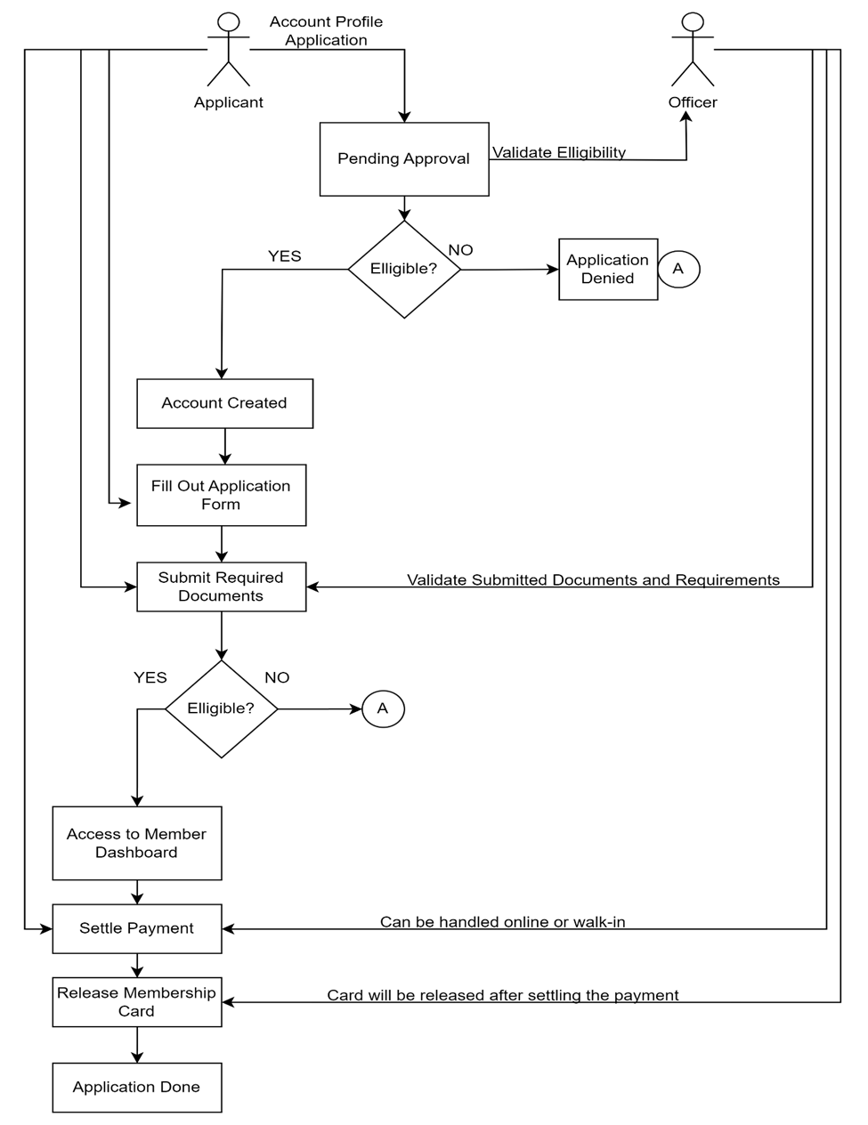

**3.4.2 Software Development Life Cycle**

The proponents utilized an Agile methodology for its execution. This method focuses on flexibility and teamwork, and continuously reassessing and for managing a project that involves constant collaboration and working in iterations. Agile project management works off the basis that a project can be continuously improved upon throughout its life cycle, with changes being made quickly and responsively.

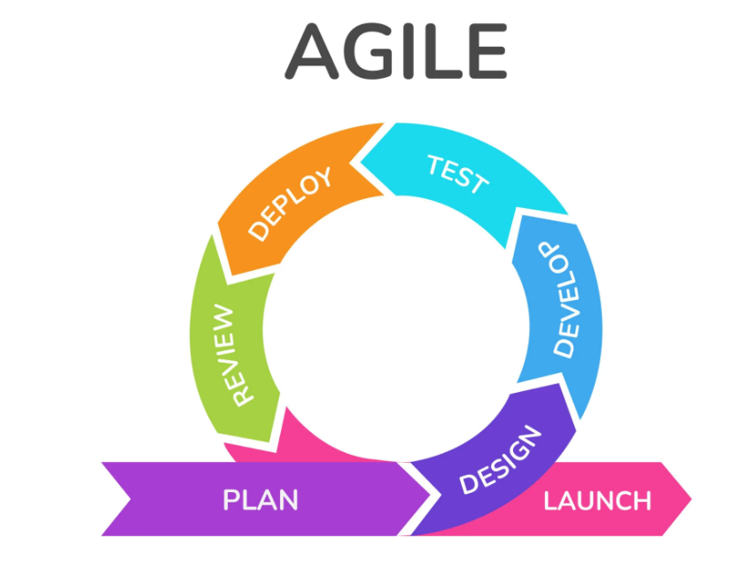

**Requirements Phase**

This is the earliest stage of the system development life cycle. The researchers set a one on one appointment with the auditor of CAPEDA in order to determine just what exactly the organization needs to improve in their existing Membership Registration System. In this stage, the proponents gathered crucial information’s such as:

1. The general background of the client.
2. The problems that they face while using their current manual system.
3. How their usual transaction works.
4. What changes they want the proposed system to possess.

**Design Phase**

This is the second phase wherein the proponents will utilize the data that they have acquired to create flow charts for each module, database, and designing the user interface. The developers ought to use HTML, CSS, and JavaScript to design the modules of the system.

**Development Phase**

         In the third phase of the System Development, the proponents used PHP and SQL to implement the coding to create the functionality of each designed module. This is when the developers make the elements of the system interact with each other to serve its purpose.

**Testing Phase**

In the testing phase of System Development, the proponents have set up an online meeting with the client using google meet to present the current progress of the system. This is where the client checks if the system is functional. Together, they will examine the whole system for possible bugs, critic its performance, and contemplate how to implement changes if necessary.

**Deployment Phase**

      In this phase, the developers will upload the web-based system in the hosting site to test its functionality when it runs online. This means that the system will finally be accessible to both the client and its potential users.

**Review**

      In the last phase, the system is reviewed by the developers and the client to confirm if the system is ready to be used, if the system has bugs or errors the cycle

**3.5** **Technical Design**

**3.5.1**    **Data Flow Diagram**

